Name: Hammad Ahmed Awan

Class: BSCS-VII, Sec ‘A’

CMS-ID: 021-19-0018

Submitted To: Sir Nisar Ahmed Siddique

MOBILE APPLICATION DEVELPOMENT

LAB NO.5

2022

**TASK 1**

**Activity 1: Create a game MadLibs.**

**CODE:**

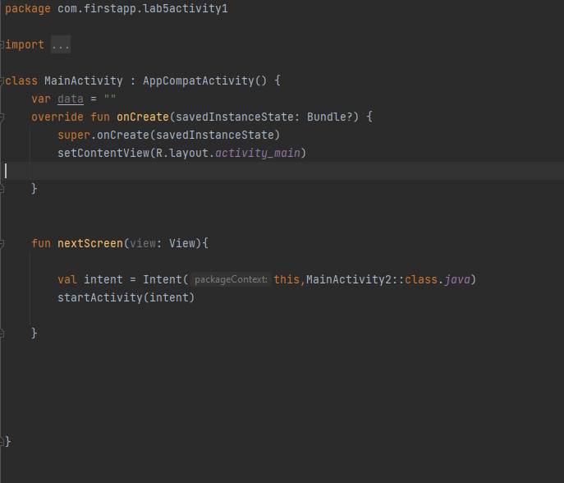

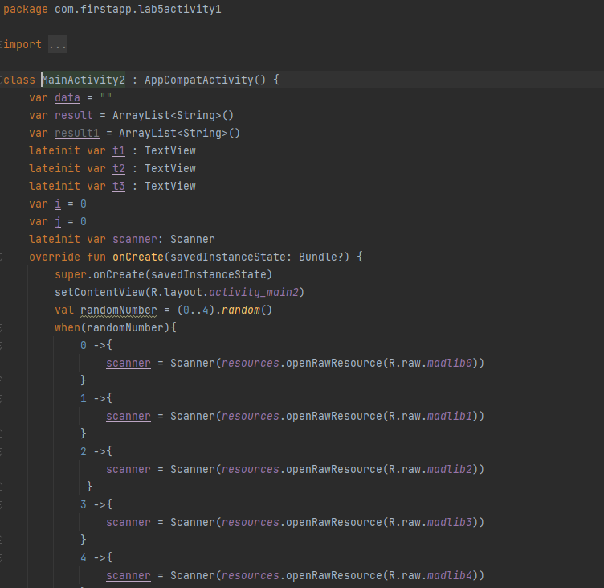

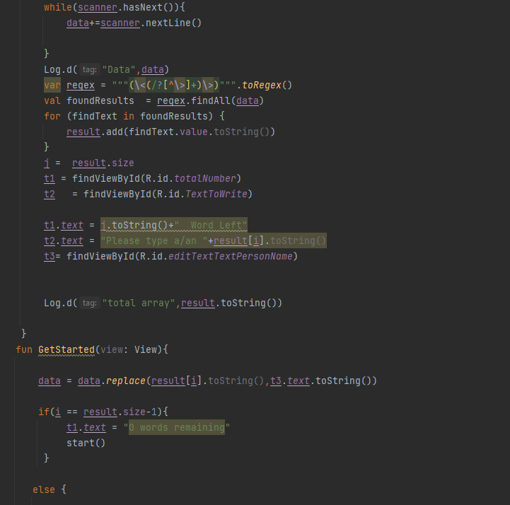

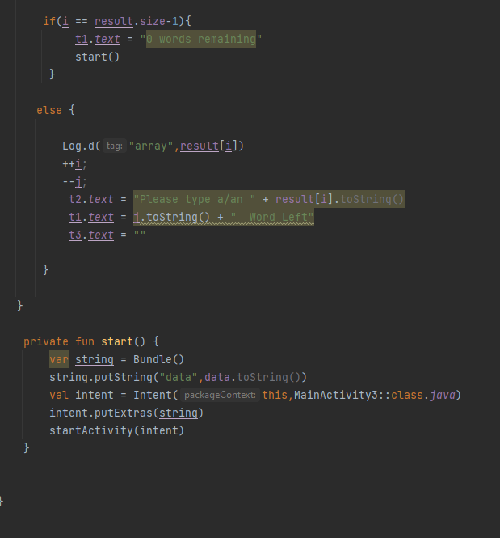

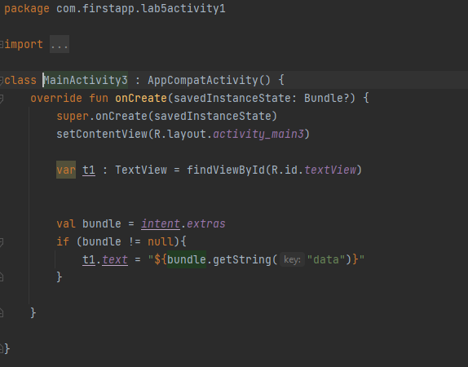

**OUTPUT:**

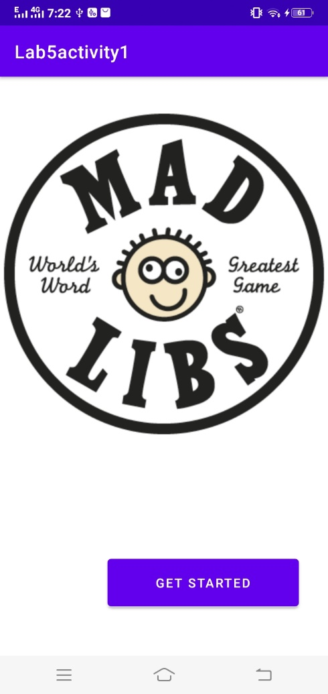

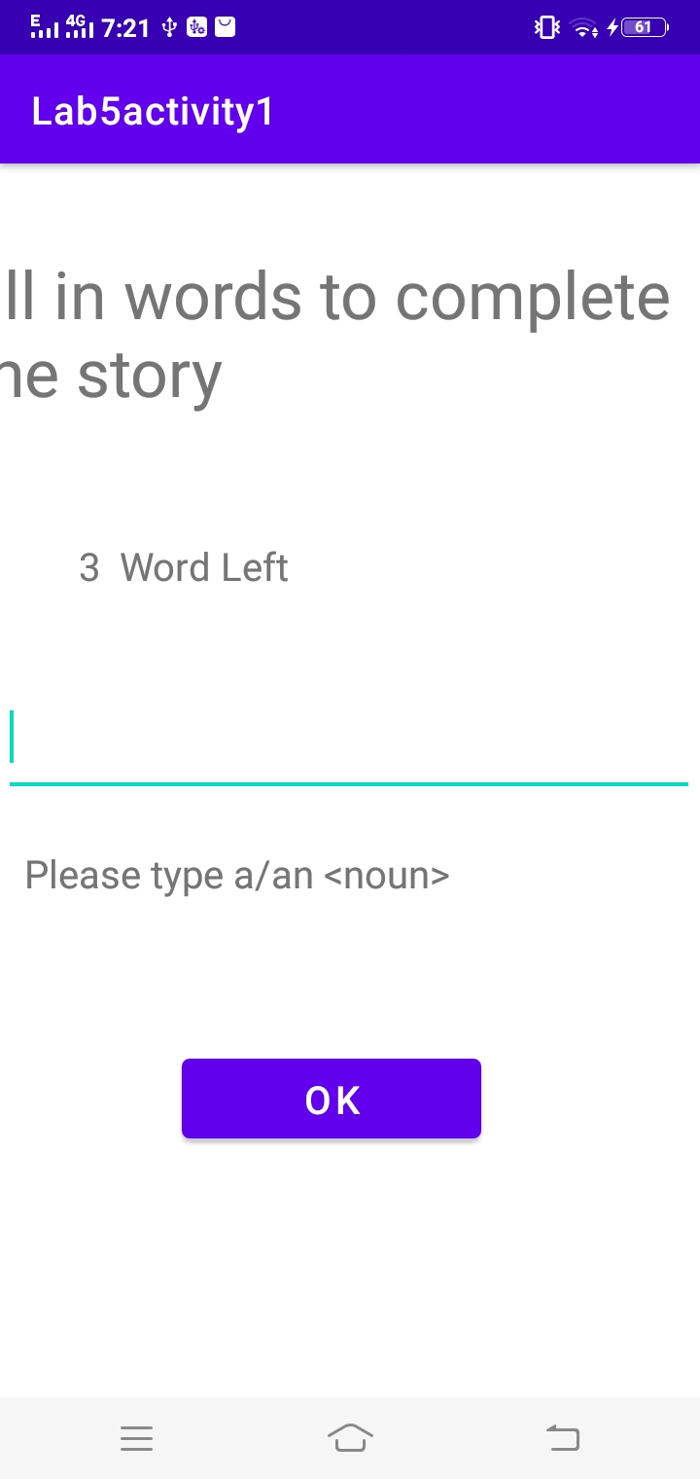

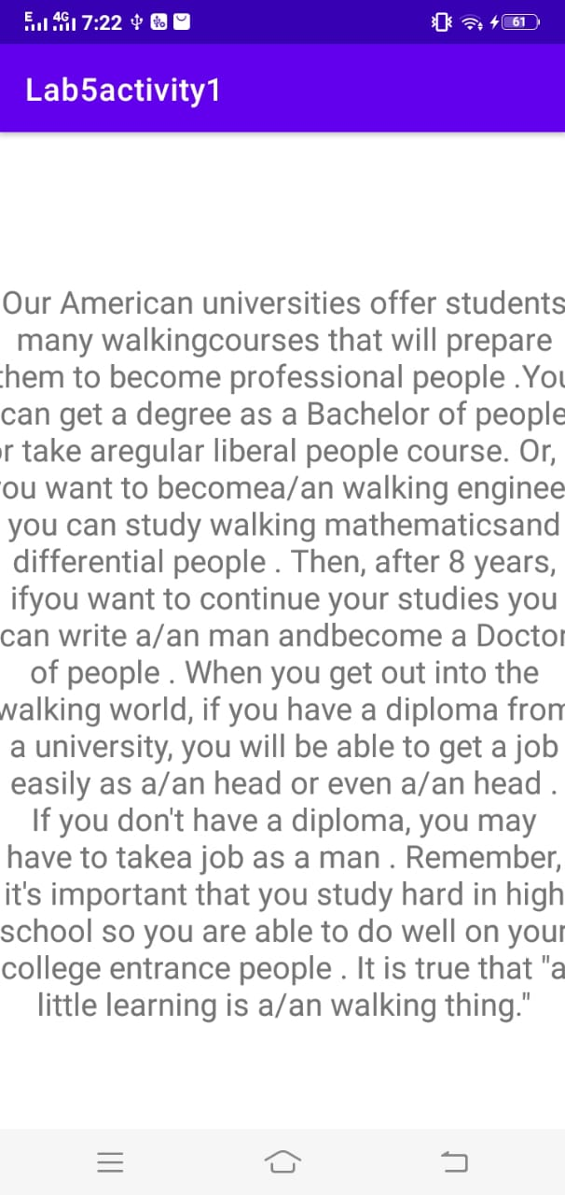

**TASK-2**

**Activity 2: Add contacts File : Steps to follow**

**CODE:** 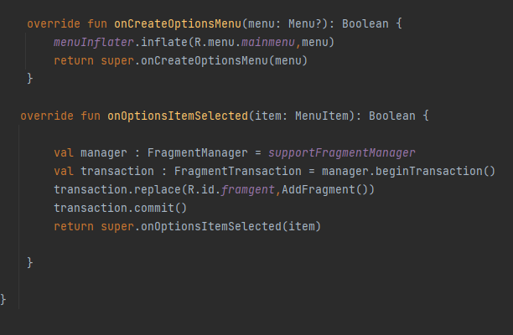

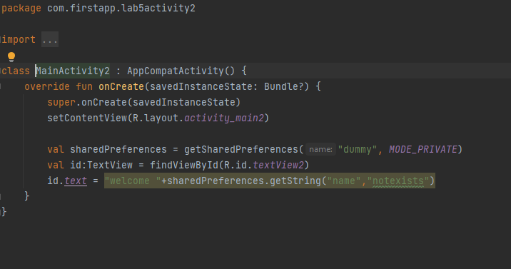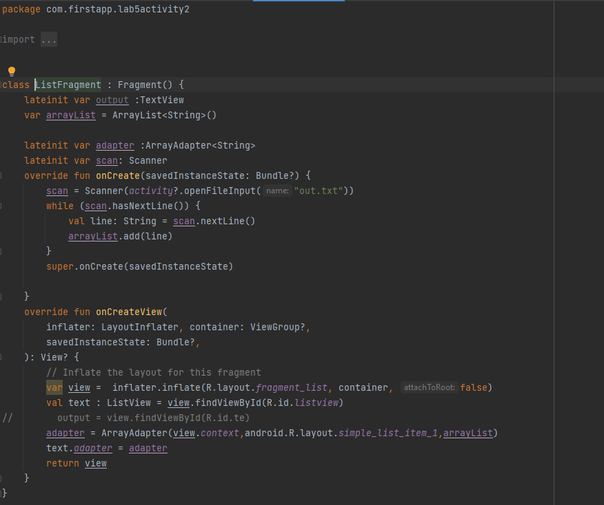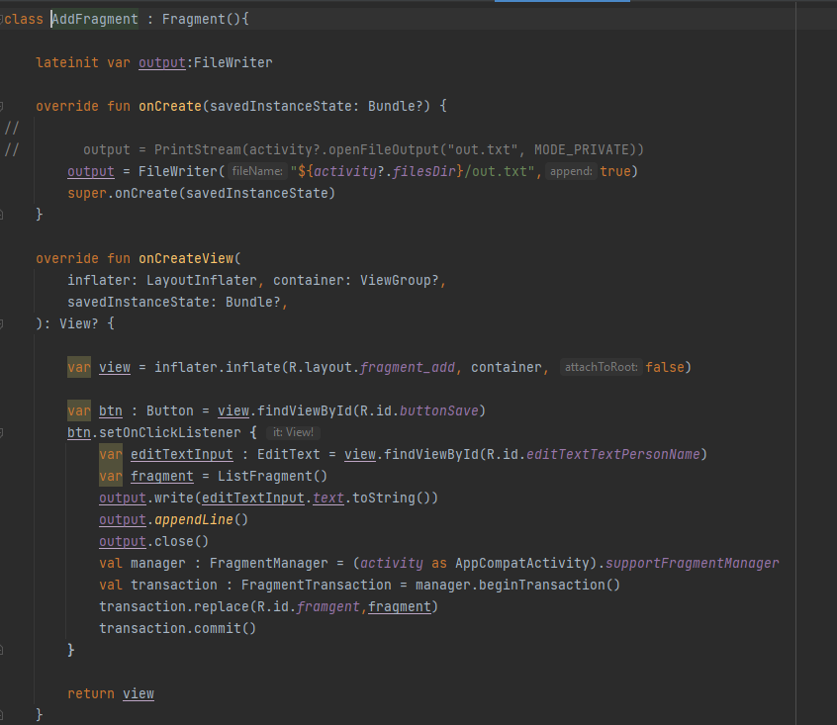

**OUTPUT:**

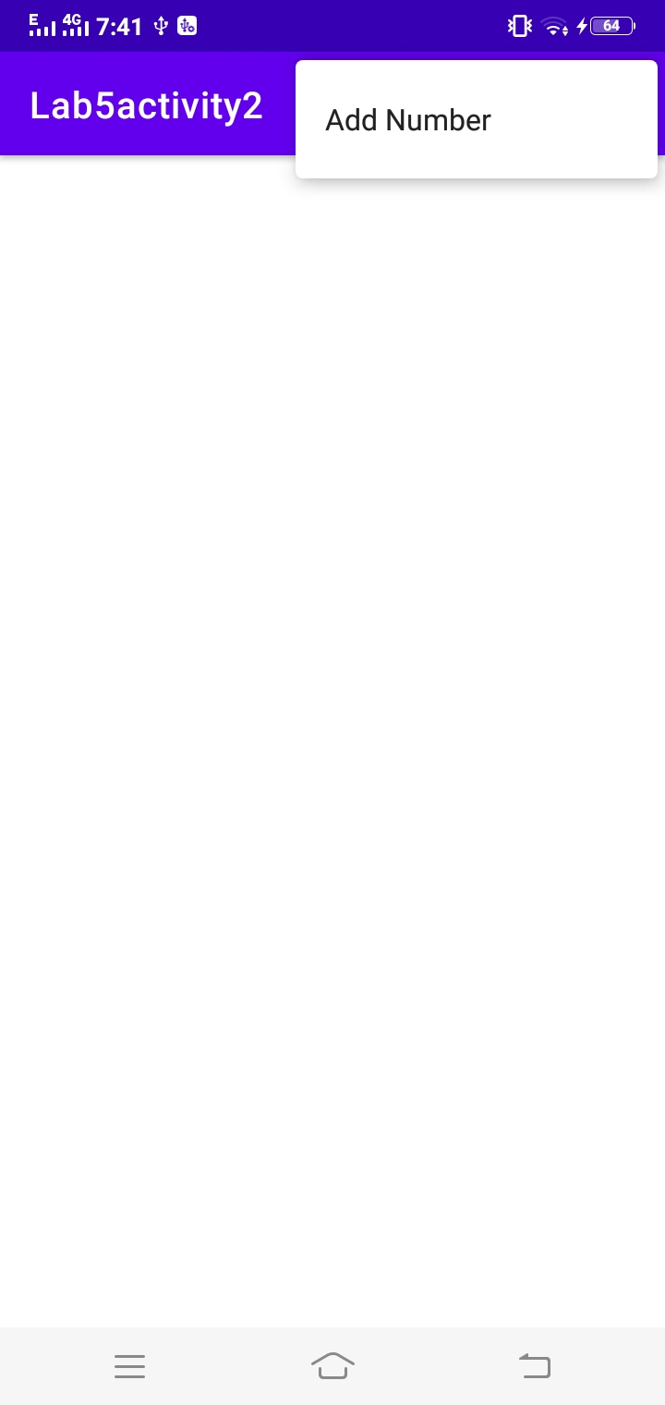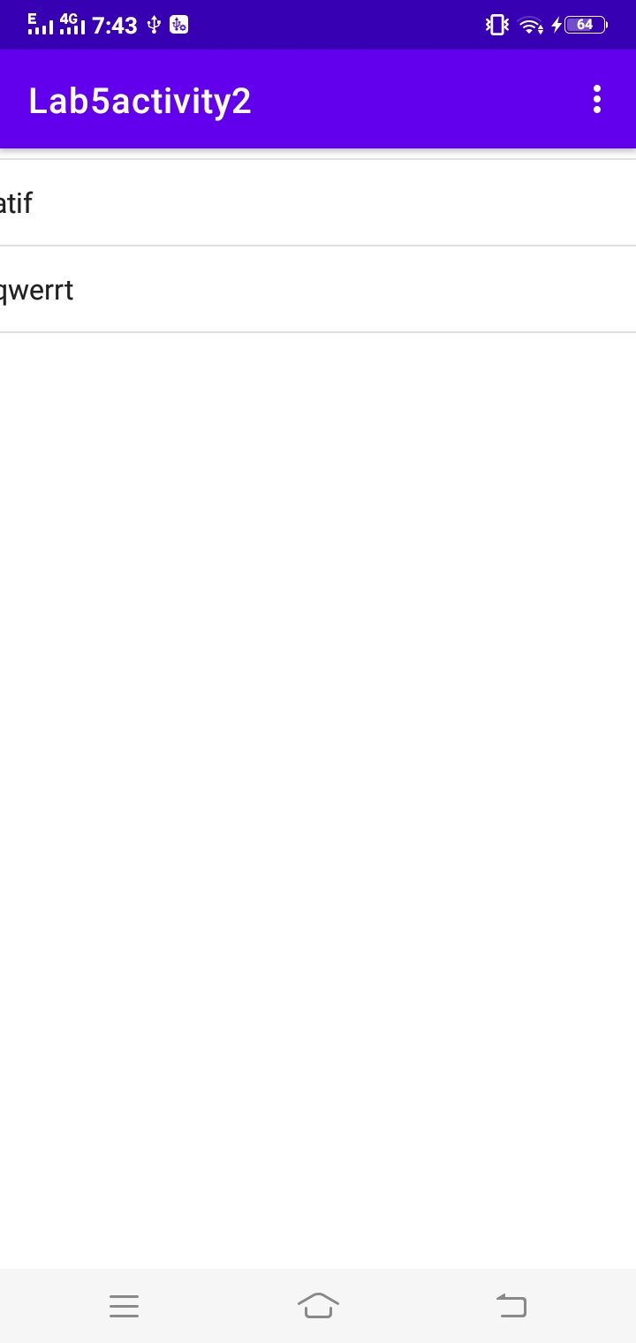

**TASK-3**

**Activity 3: Create TODO – List app.**

**- Add all the to-do list items in the file instead of storing them in memory.**

